BUILD STOCK MARKET WEB APP USING PYTHON FLASK

**What is Flask Python?**

Flask is a web framework, it’s a python module that lets you develop web applications easily. It is developed by **Armin Ronacher** who leads an international group of python enthusiasts(POCCO). It has a small and easy-to-extend core: it’s a microframework that doesn’t include an ORM(Object Relational Manager) or such features.

It does have many cool features like URL routing, and a template engine. It is a WSGI(Web Server Gateway Interface) web app framework.

**What is WSGI ?**

It is an acronym for web server gateway interface which is a standard for Python Web Application development. It is considered as the specifications for the universal interface between the Web Server and Web Application.

* First we need to install some packages
* Flask
* Jinja2
* yfinance

What is Jinja2?

Jinja2 is a web template engine which combines template with a certain data source to render the dynamic web pages.

Flask Environment Setup:

To install flask on the system, we need to have python 2.7 or higher installed on our system.

What is yfinace?

The yfinance is one of the famous modules in python, which is used to collect online data, and with it, we can collect the financial data of Yahoo. With the help of the yfinance module, we retrieve and collect the company’s financial information(such as financial ratios, etc.)as well as the histories of marketing data by using its functions. We have to install the yfinance module in our system (as it is not a built-in module in python). Once the installation process is done, we will proceed to the implementation part of the yfinance module.

**APPLICATIONS:**

* PYCHARM
* NOTEPAD
* CMD (COMMAND PROMT)
* MICROSOFT EDGE

Steps to Install Required Packages :

* There are two ways for installing required packages

1. By using CMD (command Prompt) : PIP install **Package Name**
2. By using IDLE: i) First create an project in IDLE

ii) Click on File >>>> Go to settings >>> open project

>>>>open project interpreter and install packages

**Python Script:**

Input:

#create Stock Market Web App using Flask

#import Required packages

from flask import Flask, request, render_template #import flask package

from Webapp import Webapp

flaskapp = Flask(_name_) #flaskapp = name(project name)

@flaskapp.route("/", methods=["GET","POST"])

def index():

if request.method == "POST":

ticker = request.form["ticker"]

info = Webapp.company_info(ticker)

history = Webapp.company_data(ticker)

return render_template("Home.html", info=info, history=history)

return render_template("Home.html")

if _name_ != "_main_":

pass

else:

flaskapp.run(debug=True)

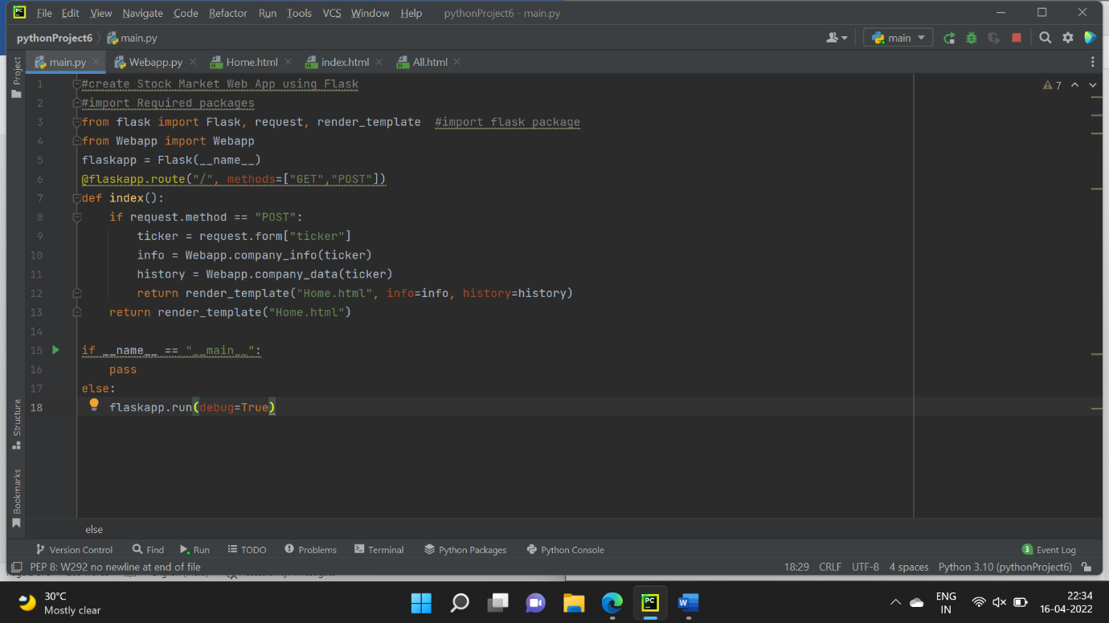

Output:

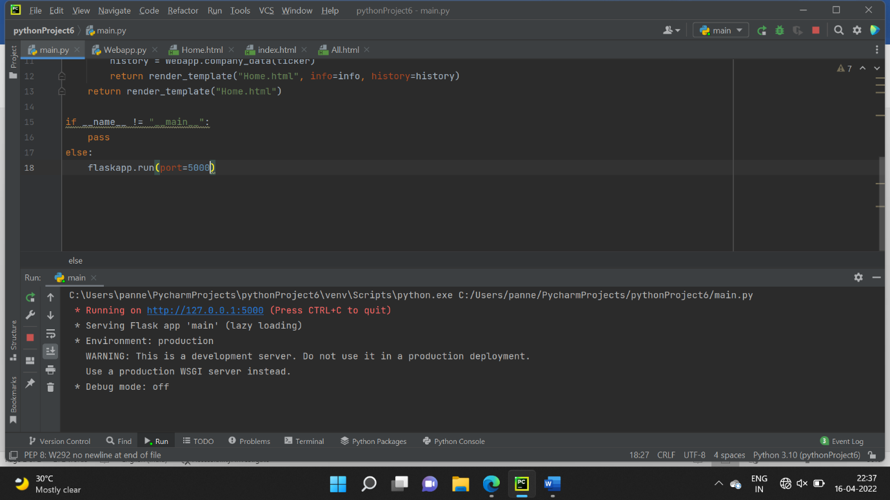

C:\Users\panne\PycharmProjects\pythonProject6\venv\Scripts\python.exe C:/Users/panne/PycharmProjects/pythonProject6/main.py

* Running on http://127.0.0.1:5000 (Press CTRL+C to quit)

* Serving Flask app 'main' (lazy loading)

* Environment: production

WARNING: This is a development server. Do not use it in a production deployment.

Use a production WSGI server instead.

* Debug mode: off

URL / Server URL : <http://127.0.0.1:5000> ( Local link )

**HTML codes:**

First.html:

{%extends 'index.html'%}

{%block body%}

<form action="" method="POST">

<div class="columns">

<div class="column is-4">

<input class="input" type="text" name="ticker" placeholder="Ticker(PNB.NS)">

<div class="container" style="margin-top:10px;">

<table class="table is-bordered is-striped is-narrow is-hoverable is-fullwidth">

<thead>

<th>Info Name</th>

<th>Info Details</th>

</thead>

<tbody>

{%for i in info%}

<tr>

<td>

{{i}}

</td>

<td>

{{info[i]}}

</td>

</tr>

{%endfor%}

</tbody>

</table>

</div>

</div>

<div class="column is-2">

<button class="button is-primary">Search</button>

</div>

</div>

</form>

{%endblock%}

Second html code:

<!DOCTYPE html>

<html>

<head>

<meta charset="utf-8">

<meta name="viewport" content="width=device-width, initial-scale=1">

<title>Welcome To Indian Stock Market</title>

<font color="red"><u> Welcome To Indian Stock Market</u></br></font>

</style>

<link rel="stylesheet" href="https://cdn.jsdelivr.net/npm/bulma@0.9.3/css/bulma.min.css">

</head>

<body>

<section class="section">

<div class="columns">

<div class="column is-2">

<aside class="menu">

<ul class="menu-list">

<li><a>Menu</a></li>

<li>

<a class="is-active">Search Stocks</a>

</li>

</ul>

</aside>

</div>

<div class="column">

{%block body%}

{%endblock%}

</div>

</div>

</section>

<footer>

<font color="black" ><u> contact address:</u><br>

</font>

<font color="green" ><span>&#x1F4E7:pannelajayakumar@gmail.com</span><br>

</font>

<font color="green"><span>&#x1F4F1:+91-9700158638</span></span>

</font>

</footer>

</body>

</html>

Web App :

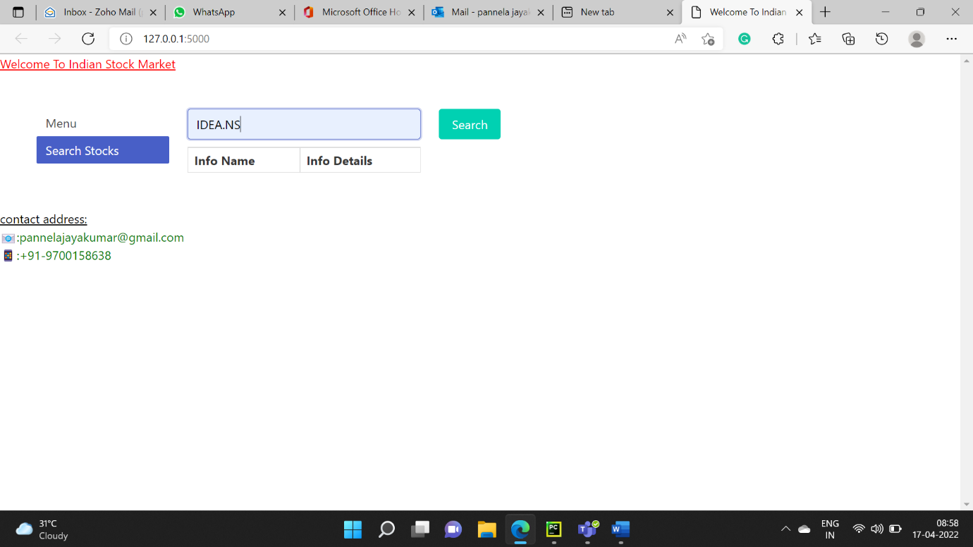

Output:

Output Link :

<https://drive.google.com/file/d/1FAcI8zvrS_oLWvfWPw3_U7xvTrwRls1a/view?usp=sharing>

**Reference :**

* <https://pypi.org/project/Flask>
* <https://html-color.codes>
* <https://www.w3schools.com/charsets/ref_emoji.asp>
* <https://youtu.be/4L_xAWDRs7w>
* <https://youtu.be/Z1RJmh_OqeA>